**Year 10 Physics End of Topic Test**

**Chapter 8.4 and 9**

**Formula you may need /41**

[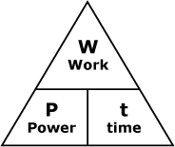](http://www.google.com.au/url?sa=i&rct=j&q=power+woek+time+triangle&source=images&cd=&cad=rja&docid=smEqr3_xk2x1UM&tbnid=FClwhBw-QCE5sM:&ved=0CAUQjRw&url=http://courses.learn60.ca/mod/book/tool/print/index.php?id=18292&ei=DKQRUvmSBoH-kgXw5oDYCg&psig=AFQjCNGFckk2PLfTo6F-_nHw8K9GjonyFA&ust=1376974213287723)

[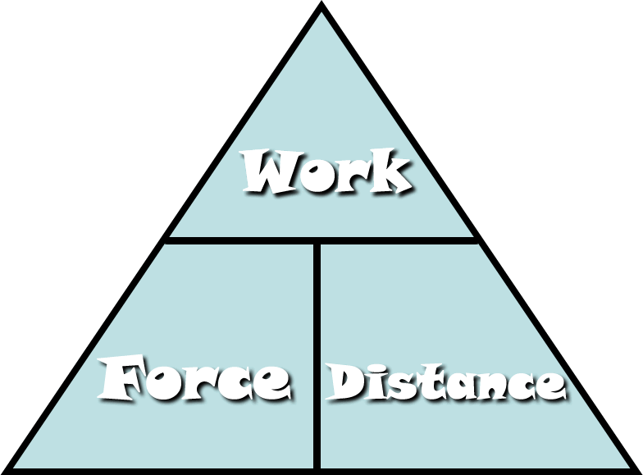](http://www.google.com.au/url?sa=i&rct=j&q=work+force+distance+triangle&source=images&cd=&cad=rja&docid=Fi7mPF8FJi6IOM&tbnid=aV4S5kcpYVNcwM:&ved=0CAUQjRw&url=http://fhm.fhsd.k12.mo.us/jhughes/Hughes/Units/Work&MachinesContent.htm&ei=0aMRUtjOGYyXkgXUoIDwCg&psig=AFQjCNG-nrT1bFGRuWdPLe1VAUwfrjBuYQ&ust=1376974154992588)

[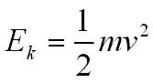](http://www.google.com.au/url?sa=i&rct=j&q=kinetic+energy+formula&source=images&cd=&cad=rja&docid=BZzVErZRq5TMSM&tbnid=KgZmomeJCTMjHM:&ved=0CAUQjRw&url=http://physicsnet.co.uk/a-level-physics-as-a2/mechanics/conservation-of-energy/&ei=UaQRUtzjCsi9kQXBxoGIDQ&psig=AFQjCNH3mfN8ppal1Ay4KsML7bw7tdoQKA&ust=1376974264173183)

[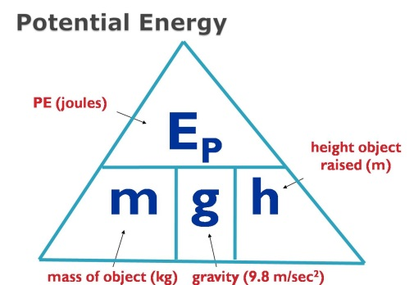](http://www.google.com.au/url?sa=i&rct=j&q=potential+energy+formula&source=images&cd=&cad=rja&docid=2H-GFaF9wBc-AM&tbnid=AD-1C8B0bBkYWM:&ved=0CAUQjRw&url=https://www.allthink.com/v/potentialenergy&ei=hqQRUs2qJsiNkAWSp4DICQ&psig=AFQjCNFHln3I7-BEBHAERUecIisFWqbMGw&ust=1376974319301500)

**Multiple Choice Answer Sheet**

1. A B C D

2. A B C D

3. A B C D

4. A B C D

5. A B C D

6. A B C D

7. A B C D

8. A B C D

9. A B C D

10. A B C D

11. A B C D

12. A B C D

13. A B C D

14. A B C D

15. A B C D

16. A B C D

**1** Power is the rate at which energy is supplied. What power is needed to supply 6000 J to lift a 15kg child 10 m up a vertical cliff face in 5 seconds?

A 1200 J/s

B 120 J/s

C 300 000 J/s

D 30 000 J/s

Cables

**[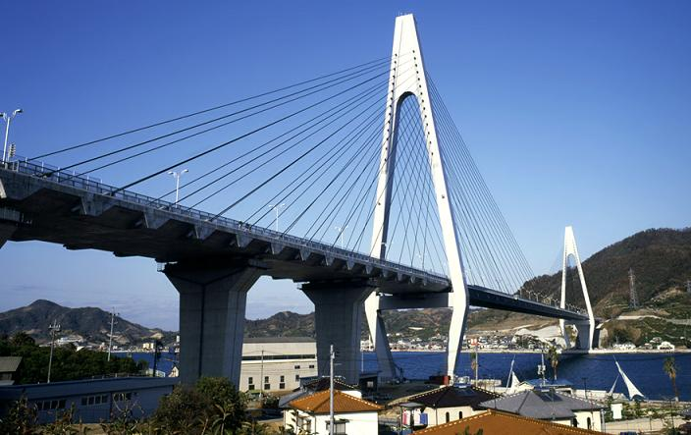](http://www.google.com.au/url?sa=i&rct=j&q=cable%20structure&source=images&cd=&docid=Ia5-jEs6rb-4pM&tbnid=kb2XZHnsRVs7bM:&ved=0CAUQjRw&url=http://www.tradekorea.com/sell-leads/0322/Suspension_Systems.html&ei=q5w7Uq_SIcvbkgWVtICYBw&psig=AFQjCNGzYY-pXnBpvpX-fhpSwjrduWiA5A&ust=1379724824159105)2** Two forces stretch a cable within a structure. Which of the following best describes the cable?

A The cable is in compression.

B The cable is in tension.

C The cable is being stretched by gravity.

D The cable is unbalanced.

**3** When a door or window sticks (is difficult to open) it indicates that the structure:

A has partly failed

B has forces acting on it

C has all of its forces balanced

D has no forces acting on it

**4** An aircraft is flying in a straight line at constant altitude and at a constant speed. What can be said about the forces on the aircraft?

A The forces are unbalanced.

B The forces are balanced.

C The forces are compression forces.

D The aircraft is accelerating.

**5** When standing, your legs are in:

A compression

B tension

C failure

D friction

**6** Sandstone is a building material that is strong under:

A compression only

B tension only

C both compression and tension

D all forces

**7** A cable was placed under tension until just before it broke. Which of the following diagrams best shows the cable just before it broke?

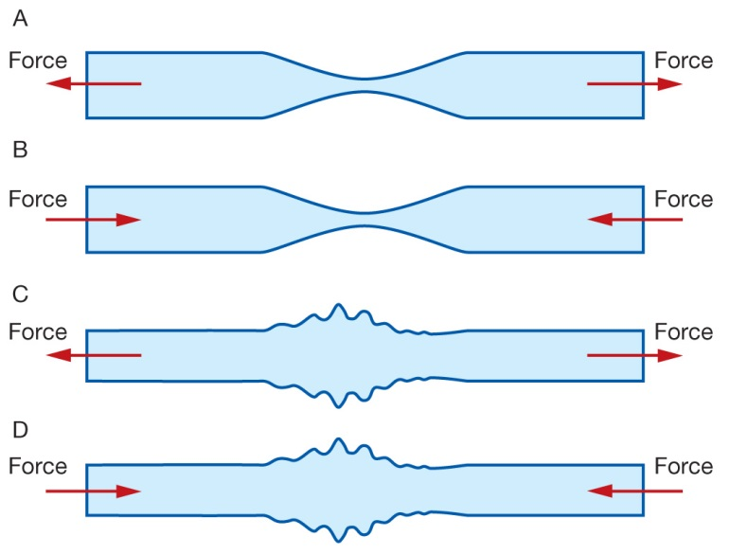

**8** The Sydney Harbour Bridge (diagram below) is an example of a:

A bowstring arch bridge

B cable-stayed bridge

C suspension bridge

D beam bridge

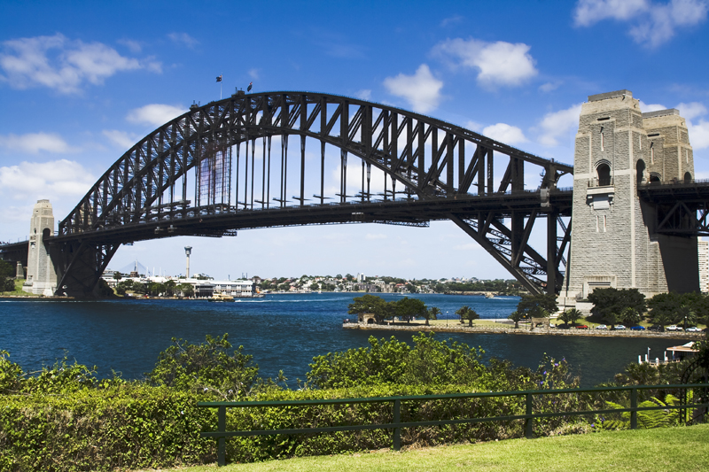

**[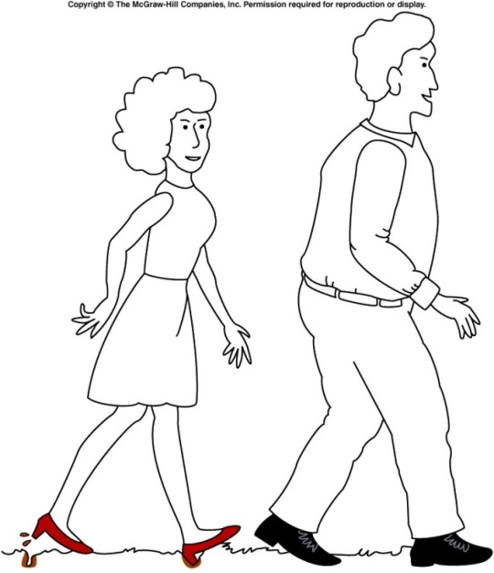](http://www.google.com.au/url?sa=i&rct=j&q=pressure+high+heel&source=images&cd=&cad=rja&docid=nxP8BgFtQrkhwM&tbnid=dVIUZoWEAPzlTM:&ved=0CAUQjRw&url=http://onlinephys.com/pressure.html&ei=hfU3Uoq9C8WfkwW2toHQAg&psig=AFQjCNGIEB4RESz64D3f84yVrSv_95GNLw&ust=1379485420790197)9** Which of the following is **true** about the diagram of the man and woman walking?

A The woman is making marks in the ground because she is placing more force on the grass

B The man is not making any marks on the ground because he is placing less force on the grass

C The woman is making marks on the ground because her shoes have less area touching the ground

D The man’s shoes are not making any marks on the ground because his have less area touching the ground

**10** Which of the following has kinetic energy?

A A bike parked on a hill.

B A child running.

C A stretched balloon.

D A bumblebee hovering in the same spot.

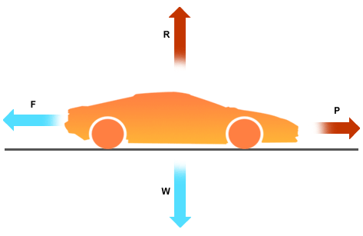

**11** Which of the following is **correct** about the movement of the car?

A The car is still

B The car is at a constant speed

C The car is accelerating

D The car is decelerating

[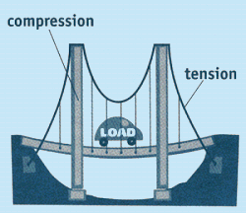](http://www.google.com.au/url?sa=i&rct=j&q=tension+and+compression+structure&source=images&cd=&cad=rja&docid=G3lxRbpcGNLJsM&tbnid=oJ5zGxfMkpJX2M:&ved=0CAUQjRw&url=http://www.carondelet.pvt.k12.ca.us/Family/Math/03210/page4.htm&ei=V9c7UomxLYzFkwXF-IDIAw&psig=AFQjCNEYORpIxQY7OLCRETbBpZif83rsvA&ust=1379739804442263)

**12** Which of the following is **true** about this diagram of a bridge?

**A**

A A shows an area under compression and B shows an area under tension

**B**

B A shows an area under tension and B shows an area under compression

C Both A and B are under tension

D Both A and B are under compression.

**13** Which of the following is **not** an example of potential energy?

A A bike parked on a hill.

B A skateboard moving down a hill

C A stretched balloon.

D A sandwich

**14** When a phone is plugged into be charged the wire and phone heat up slightly. What can be said about the phone charger

A The charger is inefficient and should be replaced

B Some heat is always ‘lost’ when energy is transformed

C The charger was left on for too long

D All of the above

**15** Mr Norgrove was holding a 300g coffee cup 2m off the ground. How much potential energy does the coffee cup have?

A 5880J

B 5880N

C 5.88J

D 5.88N

**16** After Blair got a question correct Mr Norgrove dropped his coffee cup in shock. How much kinetic energy did it have after it hit the ground?

A 5880J

B 14.406J

C 5.88J

D None

**Short Answer**

**1** Classify the following as situations in which forces are balanced or unbalanced: 4

a A motorbike is accelerating away from traffic lights.

b A car is travelling at 100 km/h straight down a freeway.

c A surfer falls off their surfboard.

d A bird flies into a window and bounces off.

**2** Explain why a stretched cable is most likely to break at a scratch. You may use a diagram to help you. 2

**3** What is the law of conservation of energy? 1

**4**. Give an example of where we can see this law in action 2

**5** Classify each of the components (labelled a, b and c) in the structure below as being in compression or tension. 3

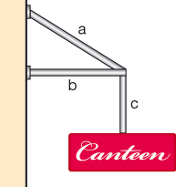a

b

c

**6** When a structure fails, it doesn’t always fall down. List two ways you can tell that some minor failure has occurred in a structure.

**SOLUTIONSMultiple Choice Answer Sheet**

1. A B C D

2. A B C D

3. A B C D

4. A B C D

5. A B C D

6. A B C D

7. A B C D

8. A B C D

9. A B C D

10. A B C D

11. A B C D

12. A B C D

13. A B C D

14. A B C D

15. A B C D

16. A B C D

**Short Answer**

**1** Classify the following as situations in which forces are balanced or unbalanced: 4

a A motorbike is accelerating away from traffic lights. Unbalanced

b A car is travelling at 100 km/h straight down a freeway. Balanced

c A surfer falls off their surfboard. Unbalanced

d A bird flies into a window and bounces off. Unbalanced

**2** Explain why a stretched cable is most likely to break at a scratch. You may use a diagram to help you. 2

Lines of stress are closer together at that point

More force in a smaller area

**3** What is the law of conservation of energy? 1

Energy may be transferred or transformed but never destroyed

4. Give an example of where we can see this law in action 2

Any suitable example (1) explained (1)

**5**` Classify each of the components (labelled a, b and c) in the structure below as being in compression or tension. 3

**a** tension

**b** compression

**c** tension

**6** When a structure fails, it doesn’t always fall down. List two ways you can tell that some minor failure has occurred in a structure. 2

Any 2 reasonable answers